**Email Setting Menubar:**

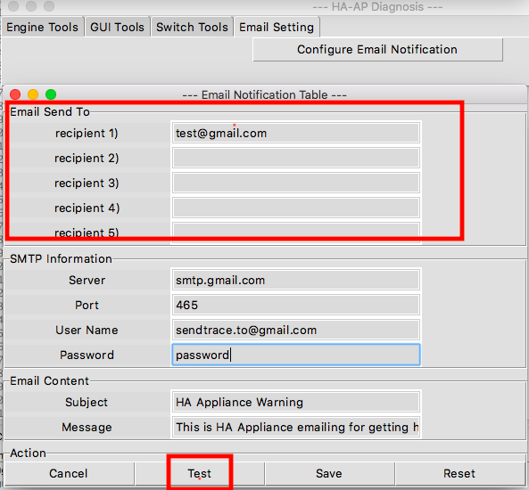

1.recipient1——recipient5，The recipient is used for debugging the Test button.

If you need to debug: the recipient's mailbox information needs to be filled in correctly, and the source code is not verified by the mailbox.

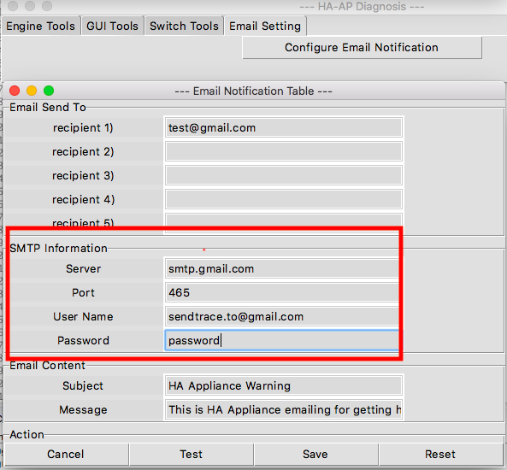

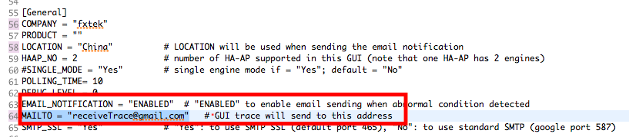

Server: you can choose gmail, Yahoo Mail, etc.

User Name：your Email

Password：your email password

The recipient of the GUI trace is in the config.ini file, you can modify it for test.

MAILTO:GUI trace will send to that address.